UCS503- Software Engineering Lab

VR MEETING ROOM

UCS 503 Software Engineering Project Report
Mid-Semester Evaluation



BE Third Year, COSE

Submitted by:

102316092 HARSH LALWANI
102316101 GURNOOR SINGH
102316114 HEMANT JINDAL
102316127 TANISH SINGLA

Submitted to:
Dr. Deep Maan

Computer Science and Engineering Department
TIET, PatialaUCS503- Software Engineering Lab

TABLE OF CONTENTS
- Introduction………………………………………………………………………………. (3-5)
1.1 Purpose of this Document ……………………………………………………………... ( 3 )
1.2 Scope of the Development Project……………………………………………………... ( 3 )
1.3 Definitions, Abbreviations, and Acronyms………………………………………….. (4 – 5)
1.4 Overview………………………………………………………………………………… (5)
- Overall Description ……………………………………………………………………... (6-8)
2.1 Product Perspective……………………………………………………………………… (6)
2.2 Technology Stack ……………………………………………………………………….. (6)
2.3 Product Functions ……………………………………………………………………….. (7)
2.4 User Characteristics ……………………………………………………………………... (7)
2.5 Constraints and Dependencies ………………………………………………………… (7-8)
- Specific Requirements ………………………………………………………………….. (8-13)
3.1 Functional Requirements ……………………………………………………………... (8-10)
3.2 Performance Requirement …………………………………………………………….... (10)
3.3 Non-Functional Requirements ………………………………………………………. (11-12)
3.4 Quality Attributes ………………………………………………………………….... (12 -13)
- Data Flow Diagram (DFD) ……………………………………………………………... (14-16)
4.1 DFD Level 0 ……………………………………………………………………….…… (14)
4.2 DFD Level 1 ……………………………………………………………………….…… (15)
4.3 DFD Level 2 ……………………………………………………………………….…… (16)
- UML Diagrams ………………………………………………………………………… (17-30)
5.1 Use-Case Diagram …………………………………………………………………….. (17)
5.2 Activity Diagram …………………………………………………………………….... (18)
5.3 Swimlane Diagram ………………………………………………………………….… (19)
5.4 User Story Card ………………………………………………………………….... (20–25)
5.5 Class Diagram ……………………………………………………………………….… (26)
5.6 State Diagram ……………………………………………………………………….… (27)
5.7 Sequential Diagram ………………………………………………………………….... (28)
5.8 Collab Diagram ……………………………………………………………………….. (29)
5.9 Deployment Diagram …………………………………………………………………. (29)
5.10 Component Diagram ……………………………………………………………….... (30)
6. Screenshot …………………………………………………………………………….… (31-35)
7. Testing …………………………………………………………………………………... (36-40)
8. Change history ………………………………………………………………………….…... (40)
9. Reference ……………………………………………………………………………….…... (41)

Software Requirements Specification (SRS)
Project: VR Meeting Room with Relay-Based Networking System
Version: 1.1
Date: 14-10-2025
- Introduction
This Software Requirements Specification (SRS) describes the functional and nonfunctional requirements for the VR Meeting Room with Relay-Based Networking System. The project integrates immersive Virtual Reality (VR) environments, AIpowered collaboration tools, and a relay-based networking infrastructure to enable seamless multi-user communication and efficient collaboration in real time.
  - Purpose of this Document

The purpose of this document is to provide a comprehensive specification of system requirements that will serve as a reference for developers, testers, and stakeholders. It defines system functionality, architecture, constraints, performance requirements, and quality attributes. This ensures a shared understanding of the project scope and objectives, while reducing risks of ambiguity during design, development, and deployment.

  - Scope of the Development Project

The VR Meeting Room system will allow users to:
- Join a shared VR environment with customizable avatars: Users can enter a common virtual meeting space and represent themselves using avatars. Avatars can be customized to match appearance or preferences, creating an immersive meeting experience.
- Communicate in real time via voice and gestures: Users can speak to each other using integrated low-latency voice chat, and perform basic gestures such as pointing or waving using VR controllers. This enables natural, human-like interaction.
- Collaborate using whiteboards and shared presentation screens: Users can write or draw on a virtual whiteboard and share documents, slides, or videos on a presentation screen. These tools help improve teamwork and group discussion.
- Connect over the internet using a relay-based system.
- The platform targets remote teams, educational institutions, training programs, and businesses requiring immersive collaboration environments.
  - Definitions, Abbreviations, and Acronyms

- Dedicated Server (Master): A central server responsible for managing the VR meeting room lifecycle, matchmaking, and coordinating communication between all connected users.
Host: A designated user who initiates the session and helps maintain synchronization of room states.
Client: Any participant who joins the meeting using a VR headset or supported device.
- Gyro support: A feature that enables full 360° movement and viewpoint tracking based on the mobile device’s gyroscope sensor. As the user physically rotates or moves their device, their view in the VR environment adjusts accordingly, creating a more immersive experience without requiring a VR controller.

- Screen sharing: A functionality that allows the presenter to broadcast their laptop or desktop screen directly into the VR environment. The shared screen appears on the virtual whiteboard or presentation board, enabling all participants to view slides, documents, or applications in real time from their respective virtual screens.

Abbreviations and Acronyms

Term | Abbreviation / Acronym
Dedicated Server (Master) | DS / DMS
Host | HST
Client | CLT
Virtual Reality | VR
Head-Mounted Display | HMD
Gyroscope Support | GS
Screen Sharing | SS
Meeting Room | MR
Real-Time Communication | RTC
Network Time Protocol | NTP
Application Programming Interface | API
Augmented Reality | AR
Virtual Environment | VE
User Interface | UI
User Experience | UX

  - Overview

Subsequent sections of this document provide detailed explanations of the core elements of the VR Meeting Room System, including:

- System architecture and technology stack: Describes the overall structure of the system, components involved, and the technologies used for development and deployment.
- Functional and non-functional requirements: Defines all system capabilities and performance expectations, including usability, reliability, and security constraints.
- Networking design (relay): Explains how the relay server handles data transmission, connection flow, synchronization, and user session management over the internet.
- Performance benchmarks and quality attributes: Specifies expected performance metrics such as latency, frame rate, scalability, and resource usage.
- Flowcharts for networking flow: Visual flowcharts illustrating how data travels between clients, host, and the dedicated server during a VR meeting session.

- Overall Description

2.1 Product Perspective
The VR Meeting Room is a multi-component distributed system consisting of:
- Unity-based VR Clients: Front-end applications running on VR headsets or supported devices, responsible for rendering the environment, handling input, gestures, and user interactions. (7.III)
- Dedicated Server: Manages matchmaking, room creation, user authentication, and session lifecycle. Ensures that all participants are connected to the correct room.
- Relay Services for reliable multiplayer communication: Handles real-time data transfer between users, ensuring reliable, low-latency communication without requiring direct peer-to-peer connections.The relay ensures low-latency, NAT-friendly multiplayer communication.
2.2 Technology Stack
- Frontend / VR Client: Unity 6000.2 LTS: Used for developing the VR interface and environment. It handles rendering, physics, user interaction, gestures, and avatar movement within the VR meeting room.
- Networking: Netcode for GameObjects + Unity Relay: Netcode manages multiplayer logic such as syncing movement, gestures, and shared objects between users. Unity Relay enables internet-based connections between clients without requiring port forwarding, ensuring reliable data transmission. (7.II)
- Voice Communication: Vivox (spatialized 3D audio): Provides real-time voice chat with 3D positional audio, meaning sound direction and volume change based on where a user is located in the virtual space, enhancing realism.
- AI Backend: Python 3.10+, NumPy, OpenCV: Used for backend processing, including computer vision tasks or automation (e.g., user detection, gesture tracking enhancements). NumPy handles calculations, and OpenCV processes visual data.(7.V)
- Simulation: Used to simulate prototype logic or lightweight tests of AI models or input behavior before integrating into the Unity VR environment. Helps in validating functionality without needing a VR headset.

2.3 Product Functions
- Immersive 3D VR meeting environments: Users can enter a virtual meeting room designed in 3D, creating a sense of physical presence and interaction similar to real-world meetings.
- Avatar creation and customization: Each user can create and personalize their own avatar, selecting appearance options to represent themselves inside the VR space.
- Real-time voice chat: Users can communicate verbally with others through integrated low-latency voice communication, enabling natural conversation during meetings.
- Interactive collaboration tools: The system supports sharing slides, documents, or screens on virtual boards, allowing multiple participants to collaborate and interact with the content.
- Secure relay-based networking: All data and communication are routed through secure relay servers, ensuring stable connections and preventing direct exposure of user IP addresses.
2.4 User Characteristics
- Organizers (Admins): Responsible for overall system and meeting management. They can create or delete VR meeting rooms, assign roles (host/moderator), control access permissions, and monitor session activities to ensure proper usage and security.
- Hosts (Moderators): Manage the active VR session. They control room synchronization, moderate interactions, initiate screen sharing or presentations, and ensure smooth flow of the meeting. Hosts can mute participants, remove users if needed, and manage collaborative tools.
- Clients (Participants): Regular users who join the VR meeting using their VR devices. They interact through avatars, communicate via voice and gestures, view shared presentations, and participate in discussions and collaborative activities.

2.5 Constraints & Dependencies
- Requires Unity 6000.2 LTS, Python 3.10+, C#, Unity relay: The project depends on Unity 6000.2 LTS for VR development, C# for scripting, and Python 3.10+ for backend/AI processing. Unity Relay is required to enable multiplayer connectivity over the internet. (7.III)
- Relay networking depends on Unity services and stable internet: All communication between VR users is routed through Unity Relay. A stable internet connection is mandatory for maintaining real-time synchronization, voice communication, and data transfer.
- Performance constraints:
◦ Voice latency less than 500ms: Voice communication must remain clear and synchronized without noticeable delay to maintain smooth real-time interaction.
◦ STT latency <600ms: Any speech recognition features must process voice input and return text within 600 ms to ensure usability during live discussions.

3. Specific Requirements

3.1 Functional Requirements

- Immersive VR Meeting Rooms
Description: The system shall provide users with customizable 3D VR meeting environments that simulate real-world settings such as conference rooms, lecture halls, or collaboration hubs.
Rationale: Enhances engagement and creates a realistic, immersive meeting experience similar to physical interaction.
Acceptance Criteria: Users must be able to join a VR meeting room within < 10 seconds after selecting a session.
- Teleportation and Locomotion
Description: The system shall allow users to navigate the VR environment through locomotion (movement using VR controllers) or teleportation for accessibility. Head rotation and direction should synchronize seamlessly with device gyroscope or VR headset tracking.
Rationale: Enables smooth and natural navigation for users across various VR devices while preventing motion sickness.
Acceptance Criteria: Movement response delay must remain under 50 ms, and navigation must feel smooth without inducing motion discomfort.

- Avatar Customization
Description Users can create their own digital identity by customizing their avatar before entering the VR meeting. They can choose different outfits, hairstyles, colors, and simple gestures—making the avatar feel more like “them.” Changes happen instantly, and users can update their look anytime during the session.
Rationale: When users feel represented in the virtual space, they engage better and feel more connected to others. Personalization helps the VR meeting feel less generic and more comfortable and inclusive.
Acceptance Criteria:
- At least five customization options must be available (e.g., outfit, hair, color theme, face presets, gestures).
- Avatar updates must appear immediately in the VR space.
- The chosen avatar should remain saved even after leaving and rejoining the session.

- Real-time Voice Chat via Vivox + Spatialized Audio
Description: Users can talk to each other inside the VR meeting using real-time, spatial 3D audio. Voices sound like they are coming from the direction of the speaker’s avatar, making conversations feel natural—just like in a real room.
Rationale: Spatial audio increases immersion and makes communication more intuitive. Users don’t just hear voices—they feel the presence of others in the virtual space.
Acceptance Criteria:
- Voice chat must remain clear with up to 50 participants.
- Audio response and transmission delay must stay under 500ms.

- Whiteboard And sticky Notes
Description: Users can collaborate using an interactive shared whiteboard. They can draw, write, or place digital sticky notes that everyone in the meeting can see. This allows brainstorming, explaining concepts, or capturing quick ideas in real time.
Rationale: Proper lifecycle control ensures that sessions run smoothly, prevents unused rooms from consuming resources, and maintains a structured meeting flow.
Acceptance Criteria:
- A room should be created or terminated within < 5 seconds.
- Only authorized users (Organizers/Hosts) can perform these actions.

- Room Lifecycle Management

Description: Organizers and Hosts should be able to create new VR meeting rooms, manage ongoing sessions (such as admitting users, muting, or ending the session), and cleanly terminate rooms when the meeting is over. The system will handle room creation, user allocation, and cleanup automatically in the backend.
Rationale: Proper lifecycle control ensures that sessions run smoothly, prevents unused rooms from consuming resources, and maintains a structured meeting flow.
Acceptance Criteria:
- A room should be created or terminated within < 5 seconds
- Only authorized users (Organizers/Hosts) can perform these actions.

- End-to-End Encryption
Description: All communication between users—including voice data, shared content, and collaboration data—shall be encrypted end-to-end. This ensures that no third party, including server operators, can intercept or access the data being transmitted.
Rationale: Protects user privacy and prevents unauthorized access or data leakage during meetings, especially in sensitive discussions.
Acceptance Criteria:

- The system must enforce AES-256 or TLS 1.3 encryption for all communication channels.
- Data should remain encrypted throughout transmission until it reaches the target user.
3.2 Performance Requirements
- Voice communication latency shall remain under 500ms, ensuring real-time, natural conversation without noticeable delay.
- The system shall support at least 10 concurrent users per VR room while maintaining smooth visuals, stable audio, and responsive interactions.
- Performance must remain consistent even during active collaboration activities (whiteboard usage, screen sharing, avatar movement).
3.3 Non – Functional Requirements
- Reliability
Description: The system shall automatically reconnect users if they temporarily lose internet connectivity and restore them back into the active meeting session.
Rationale: Ensures meetings continue smoothly without interruptions or forced restarts due to connection drops.
Acceptance Criteria:
- Reconnection must occur automatically within < 5 seconds once the network is restored.
- User state (role, room presence, voice connection) must be preserved.
- Scalability
Description: The system shall scale horizontally to support multiple VR meeting rooms and additional users without performance loss.
Rationale: Allows the system to grow and handle more participants and rooms as usage increases.
Acceptance Criteria:
- New meeting rooms can be created instantly on demand.
- System performance remains stable when more rooms/users are added.
- Portability
Description The system shall operate across different VR platforms, including Standalone VR headsets and PC-VR setups, without requiring platform-specific changes.
Rationale: Improves accessibility and increases the target user base by supporting multiple hardware environments.
Acceptance Criteria:
- Application builds successfully for both Standalone VR and PC-VR.
- All core features work consistently across supported platforms.
- Usability
Description: The system shall offer intuitive VR interaction and require minimal learning effort to navigate, interact, and communicate.
Rationale: Enhances user adoption by making the system easy to use for first-time VR users.
Acceptance Criteria:
- A new user can join a room and begin interacting within < 2 minutes.
- Core interactions (movement, speaking, using tools) require no more than 2–3 steps.

- Security

Description: All communication—including voice, data, and collaboration content—shall be encrypted end-to-end. User roles shall determine access control.
Rationale: Protects sensitive meeting information and prevents unauthorized access or data interception.

Acceptance Criteria:
- Uses AES-256 or TLS 1.3 encryption for all data transmission.
- Only authorized roles (Organizers/Hosts) can manage room actions.

3.4 Quality Attributes
Term | Description
Performance | Ensures smooth, low-latency interactions, stable FPS, and optimized real-time communication.
Reliability | Guarantees continuous operation without crashes or session drops.
Scalability | Supports increasing users, rooms, and resources without performance loss.
Availability | Keeps the VR meeting system accessible with high uptime and reliable services.
Usability | Provides an intuitive, easy-to-navigate interface for VR interactions and features.
Maintainability | Uses modular, clean architecture for easy updates, bug fixes, and feature additions.
Security | Protects user data, communication, and access through secure protocols and authentication.
Interoperability | Works consistently across VR headsets, mobile (gyro), desktop, and other platforms.
Portability | Runs efficiently on multiple platforms (Android, Windows, WebXR) with minimal changes.
Extensibility | Allows new features, tools, and modules to be added without major redesign.
Responsiveness | Reflects user actions (movement, interactions, voice) quickly in the VR environment.
Data Integrity | Ensures accurate, consistent meeting data and synchronized states across all clients.

4. Data Flow Diagram

4.1. DFD Level 0
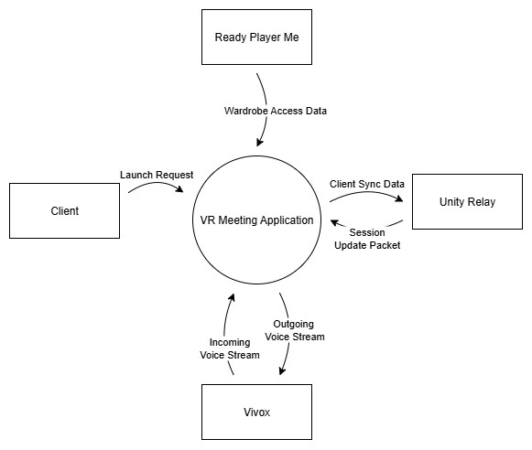
Fig 1 : DFD level 0
Narrative Descrption : his Level 0 Data Flow Diagram provides a high-level overview of the VR Meeting Application’s external interactions. It shows how the client sends launch requests, retrieves wardrobe data from Ready Player Me, exchanges synchronization packets with Unity Relay, and processes voice streams through Vivox. The diagram illustrates the primary data inputs and outputs that drive the system’s core functionality.

4.2. DFD Level 1

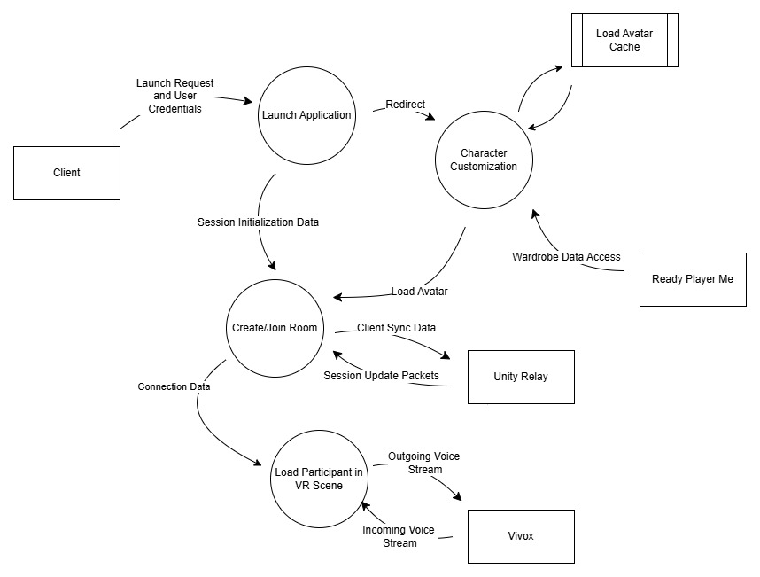
Fig 2 : DFD level 1
Narrative descrption : This diagram illustrates the complete VR Meeting Room workflow, covering avatar loading, room creation, data synchronization, and real-time player management. It shows how the client interacts with external services like Ready Player Me, Unity Relay, and Vivox. The flow highlights the movement of session data, voice streams, and avatar information throughout the system. Overall, it provides a comprehensive view of interconnected processes enabling a seamless VR meeting experience.

4.3. DFD Level 2

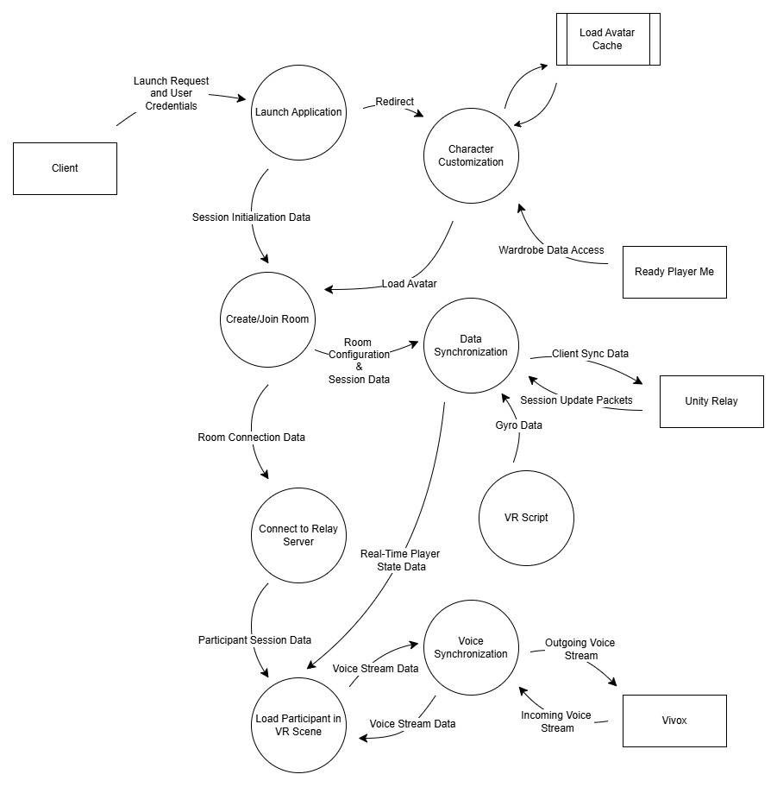
Fig 3 : DFD level 2
Narrative description : This diagram presents a streamlined view of the VR Meeting Room interaction sequence, from application launch to avatar customization and room creation. It outlines how session data, avatar assets, and synchronization packets flow between the client and external services. Key components such as Unity Relay and Vivox facilitate real-time updates and audio communication. The flow emphasizes essential system interactions required to load participants into the VR environment.

5. UML Diagrams

5.1. User-Case Diagram
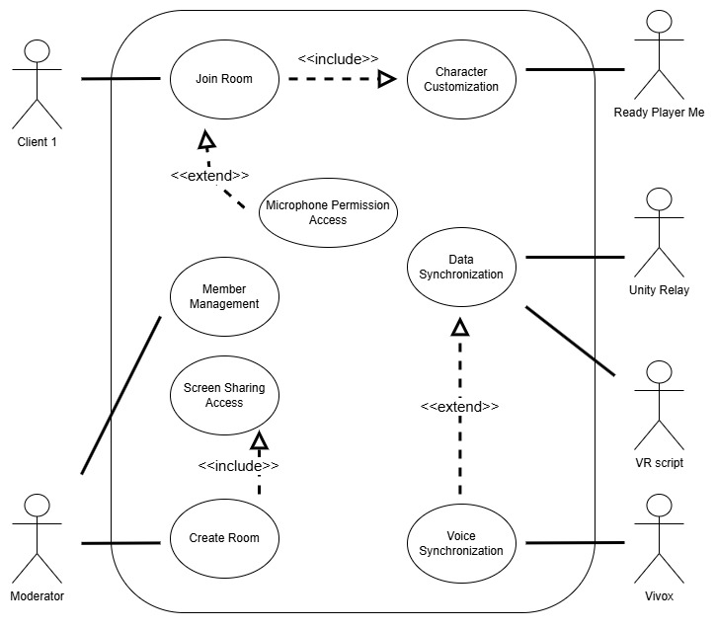

Fig 4 : User-Case Diagram

Narrative Descrption : This use-case diagram illustrates the core interactions within the VR Meeting Room system, involving clients, moderators, and external services. It highlights essential processes such as room creation, joining, member management, and data synchronization. The diagram also depicts included and extended behaviors like character customization, microphone access, and voice synchronization. Overall, it provides a clear overview of how users and system components collaborate to enable seamless VR meeting functionality.

5.2. Activity Diagram

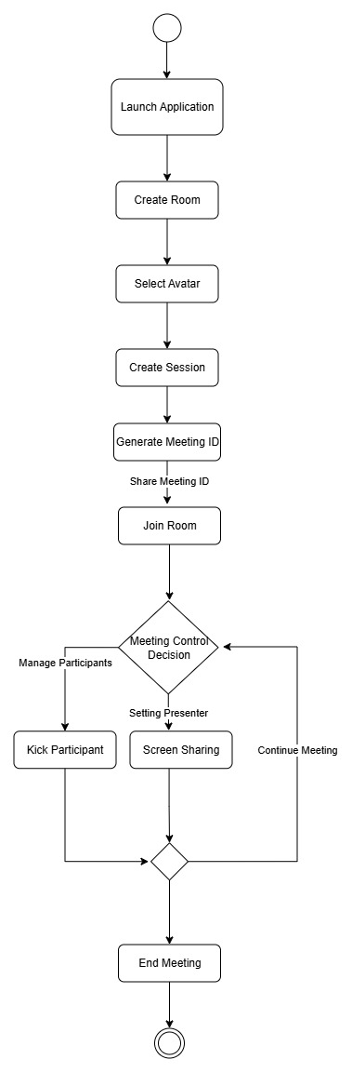

Fig 5 : Activity Diagram
Narrative Descrption : This flowchart outlines the complete workflow of the VR Meeting Room system, from launching the application to creating a room, selecting an avatar, and generating a meeting ID. Users then join the session and manage meeting controls such as screen sharing, presenter settings, and participant removal. The diagram also shows decision points that guide meeting continuation or administrative actions. The process concludes with the host ending the meeting.

5.3. Swimlane Diagram

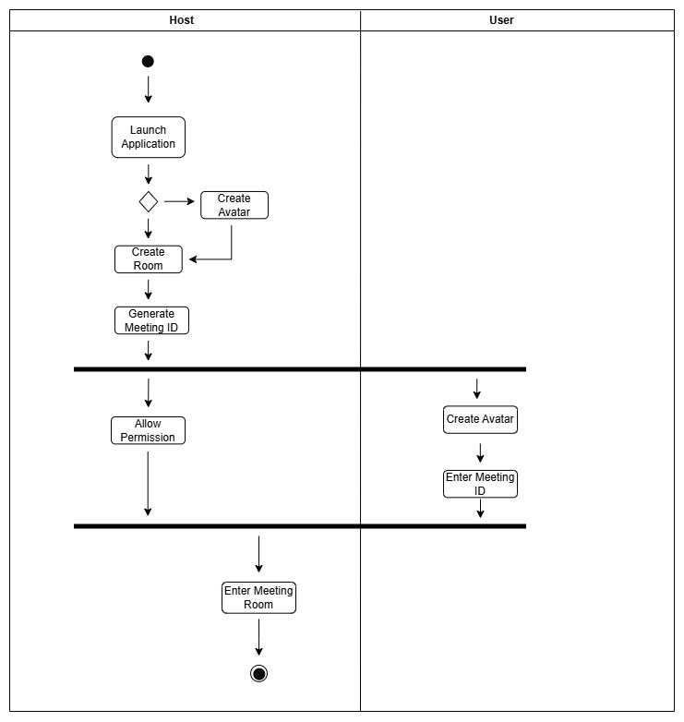

Fig 6 : Swimlane Diagram
Narrative Description : This swimlane diagram illustrates the workflow division between the host and the user in the VR Meeting Room system. It shows how the host manages room creation, session setup, and permissions, while the user joins the meeting using the shared meeting ID. Each activity is clearly separated by swimlanes to highlight role-based responsibilities. The diagram provides a structured view of coordinated actions leading to a successful meeting session.
  - User Story Card
5.4.1 User Story Card 1 : Joining and Creating Meeting Room

Front of Card
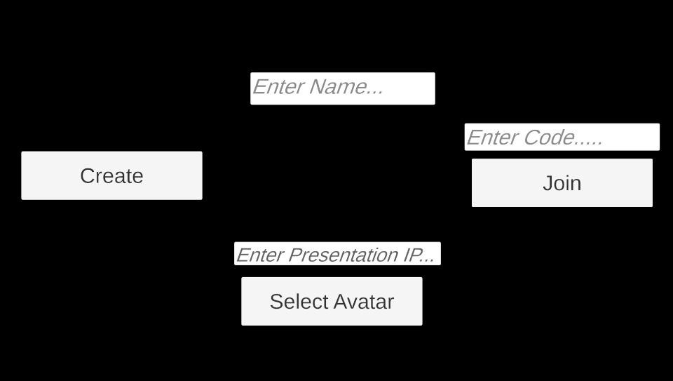
USER LOGIN

User Statement:

As a user, I want to join a virtual meeting room in VR where I can customize my
communicate with others through voice, and experience real-time interaction

using Unity Relay and Vivox services.

Back of Card

Success Scenarios
The system successfully:
- Launches and authenticates the user
- Establishes a stable connection to Unity Relay for multiplayer synchronization
- Connects to Vivox for real-time voice communication
- Displays all participants in the VR scene accurately
- Maintains smooth data and voice synchronization throughout the session

Failure Scenarios
The system fails when:
- The application fails to initialize or loses connection
- Unity Relay cannot establish a room or session link
- Vivox connection drops or times out
- Participant data is not synchronized properly
- The app crashes or disconnects mid-session

5.4.2 User Story Card 2 : Avatar Customization (Ready Player Me Models)

Front of Card

User Statement:

As a participant entering the VR meeting room, I want to choose an avatar from a set of premade Ready Player Me (RPM) models, So that I can represent myself visually and personalize my appearance inside the VR meeting room.

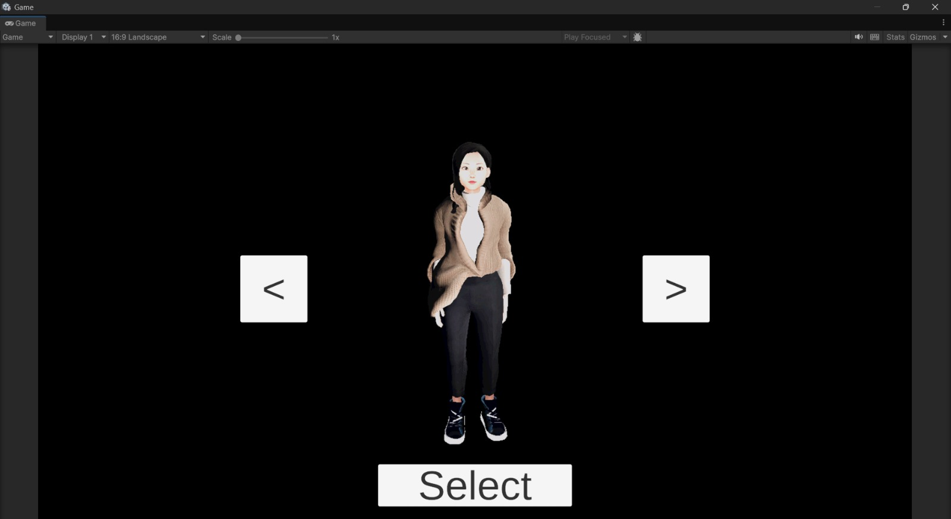

Back of Card

Success Scenarios
  - User can view a list of available Ready Player Me avatars on the lobby screen.
  - User can preview each avatar in 3D before selecting.
  - System loads the selected avatar within 3 seconds.
  - The avatar must appear correctly in the meeting room when the user joins.
  - Other participants must see the correct avatar instantly through network sync.

Failure Scenarios
  - If avatar loading fails, a default avatar is assigned.
  - If Ready Player Me model fetch fails, system shows an error and blocks selection.

5.4.3 User Story Card 3 : Presentation Request + Moderator Approval

Front of Card

User Statement:

As a participant in the VR meeting room, I want to request permission from the Moderator to present on the whiteboard/screen, So that I can share my slides or content only when granted presenting rights.

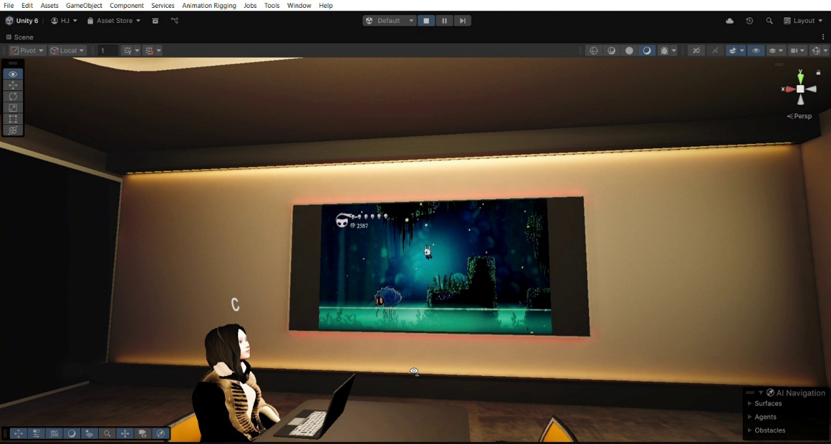

Back of Card

Success Scenarios
  - User presses “Request to Present” button.
  - Moderator receives a notification and can Approve/Deny.
  - If approved, the user gains access to whiteboard/screen tools.
  - Only one presenter at a time can control the screen.
  - All presentation actions (slide next, previous, highlight, draw) sync to every participant within 300 ms.

Failure Scenarios
  - If Moderator denies the request, user does not gain presentation controls.
  - If presenter disconnects, permissions are revoked automatically.
  - If network or relay fails, system cancels presentation mode.

5.5 Class Diagram
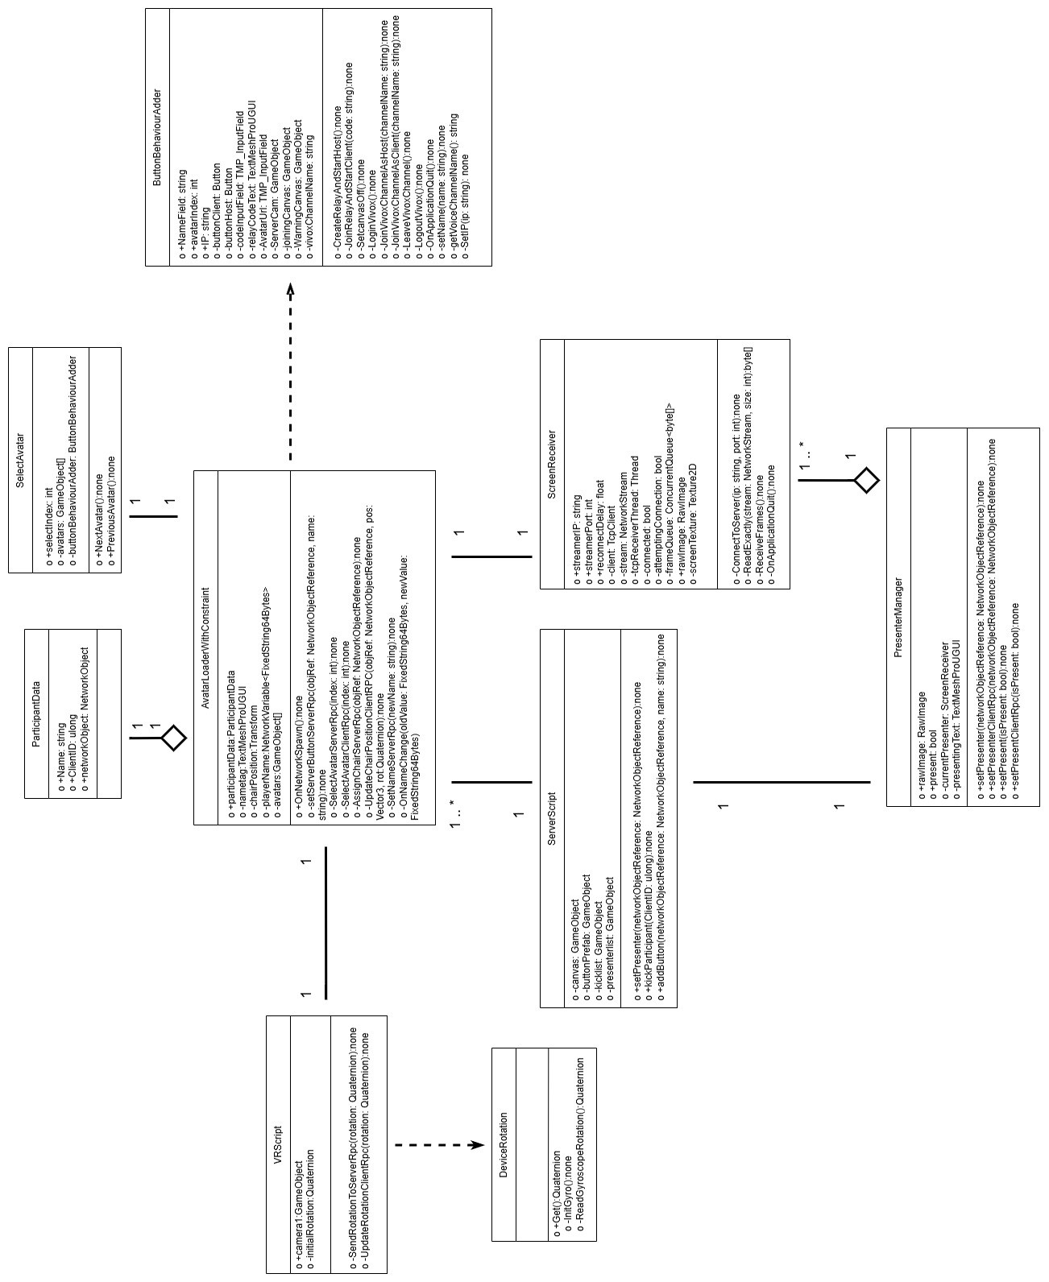

Fig 7 : Class Diagram

  - State Diagram
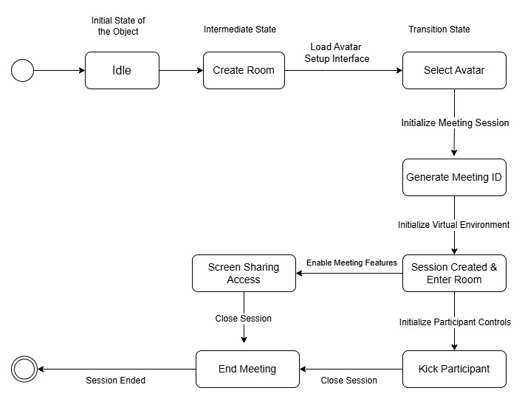
Fig 8 : State Diagram
Narrative Description : This state diagram represents the lifecycle of a VR meeting session, beginning from the idle state and progressing through room creation, avatar selection, and meeting initialization. It captures key transitions such as generating the meeting ID, enabling screen sharing, and managing participants. The diagram also shows control actions like kicking a participant and ending the meeting. Overall, it outlines how the system moves between states to support a complete meeting flow.
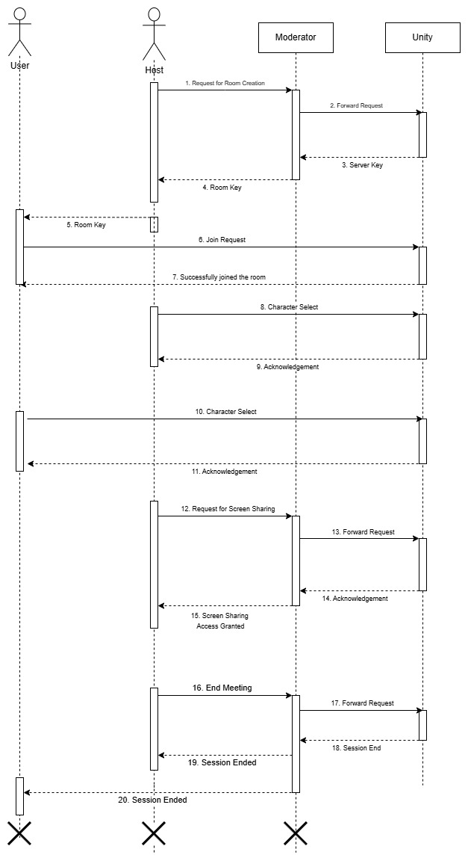
  - Sequential Diagram
Fig 9 : Sequential Diagram
5.8 Collab Diagram

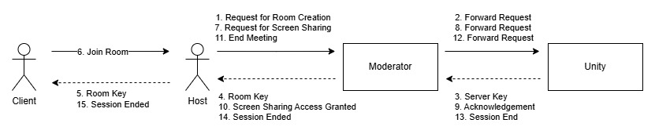

Fig 10 : Collab Diagram

5.9 Deployment Diagram
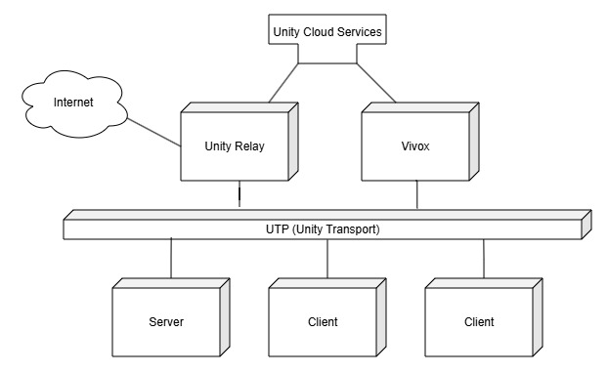

Fig 11: Deployement Diagram

5.10 Component Diagram

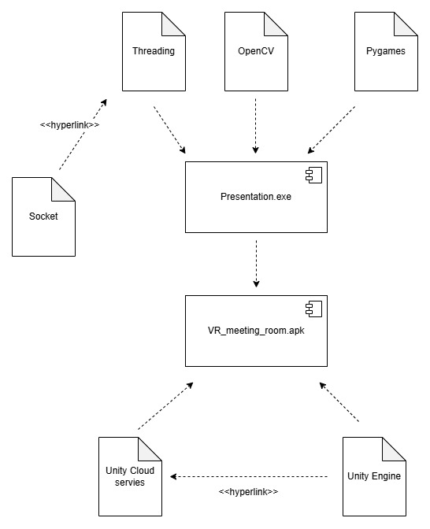
Fig 12 : Component Diagram
\

  - Screenshots

6.1 User Dashboard

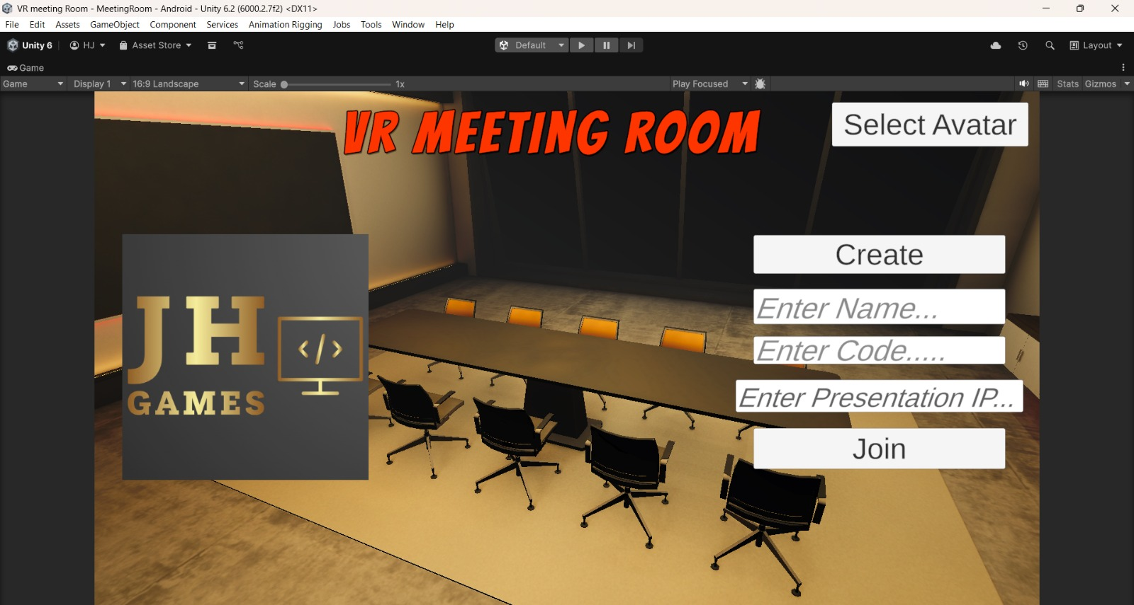

Description : This scene shows the welcoming lobby screen of a VR Meeting Room app. A stylish conference room sits in the background, lit warmly with a long table and chairs set up as if waiting for a team to join. On the right, simple buttons let the user pick an avatar, create a room, or join a meeting by entering their name and a code. On the left, the JH Games logo adds a personal touch. The whole layout feels clean, modern, and ready for someone to step into a virtual meeting.

6.2 Living Room /lobby/home interface

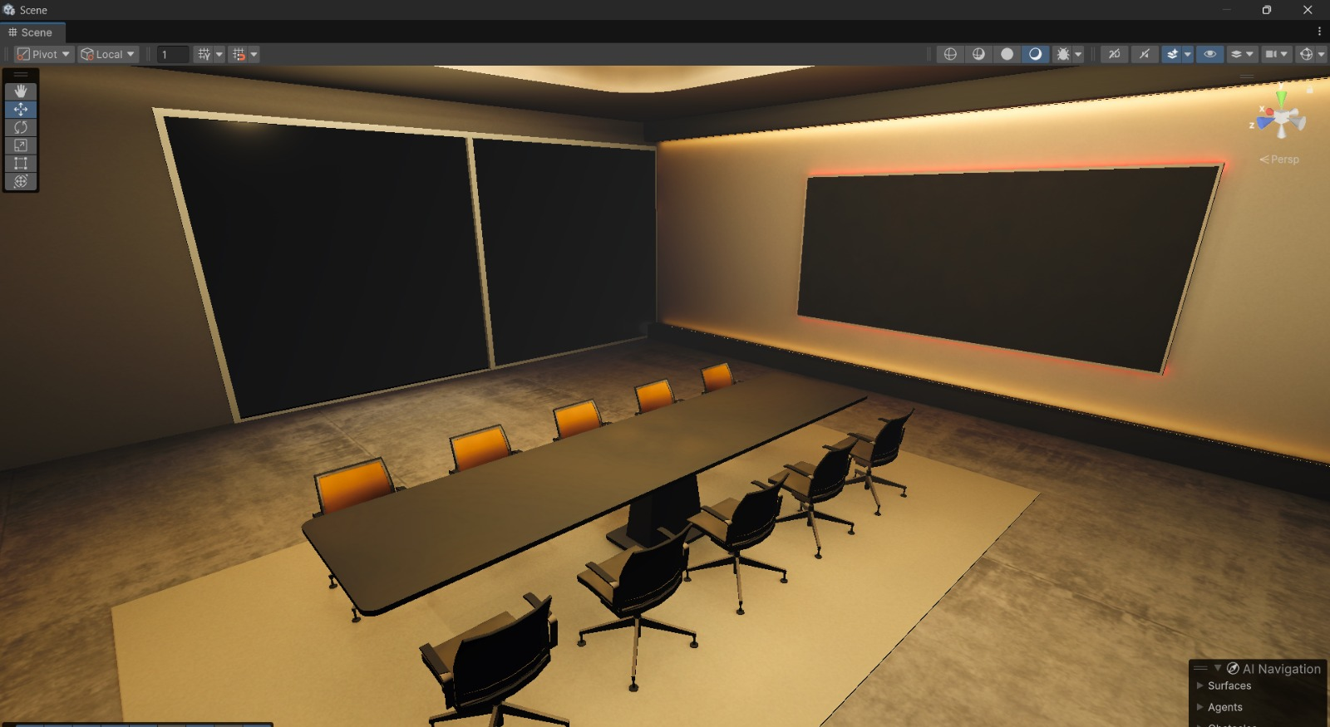
Description : This scene presents a well-designed virtual conference room featuring a long central meeting table surrounded by ergonomic chairs. The environment is illuminated with soft, ambient lighting that highlights the large presentation screen mounted on the wall. The clean layout, neutral color palette, and organized seating arrangement create a professional atmosphere suitable for meetings, presentations, and collaborative VR interactions.

6.3 Avatar customization inteface

Descrption : This scene displays the avatar customization interface, featuring a central 3D character model against a plain black background for clear visibility. Navigation buttons on the left and right allow the user to cycle through different avatar options, while a prominent “Select” button at the bottom confirms the chosen model. The layout is minimalistic and focused, ensuring an easy and distraction-free selection process for users preparing their virtual identity.

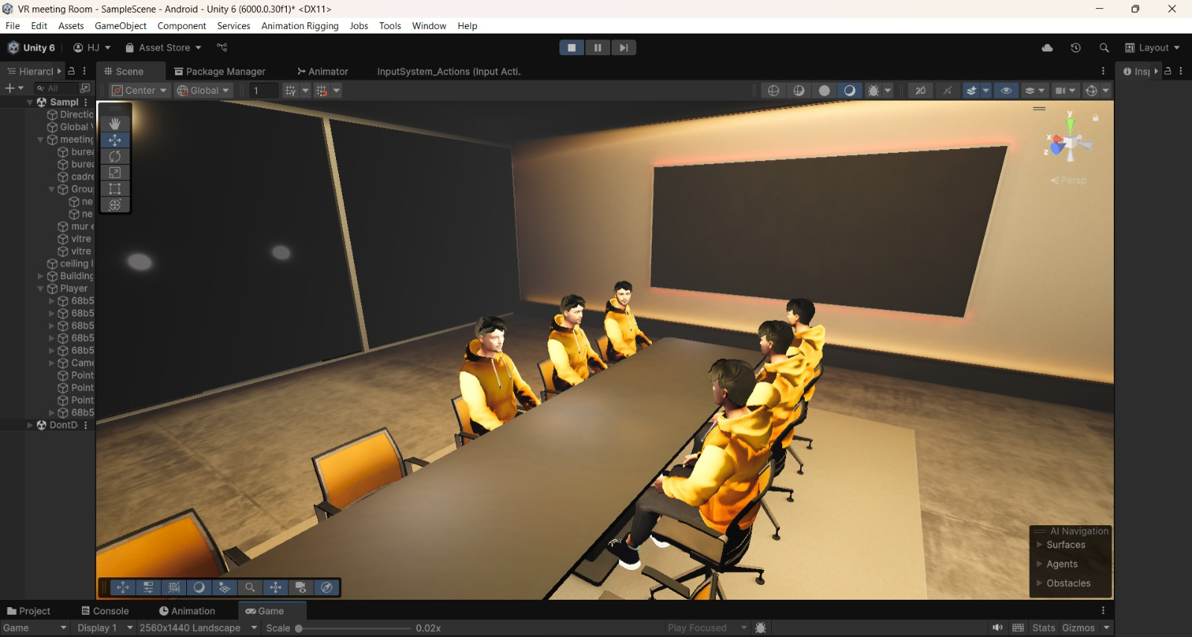
6.4 In-Meeting VR Interaction Scene

Description : This scene represents a virtual meeting in progress within the VR conference room environment. Multiple avatars are seated around the central meeting table, each positioned to face one another in a natural discussion layout. The warm ambient lighting and large presentation screen on the wall help create a realistic, professional atmosphere. The arrangement demonstrates how users can interact, communicate, and collaborate within the virtual meeting space.

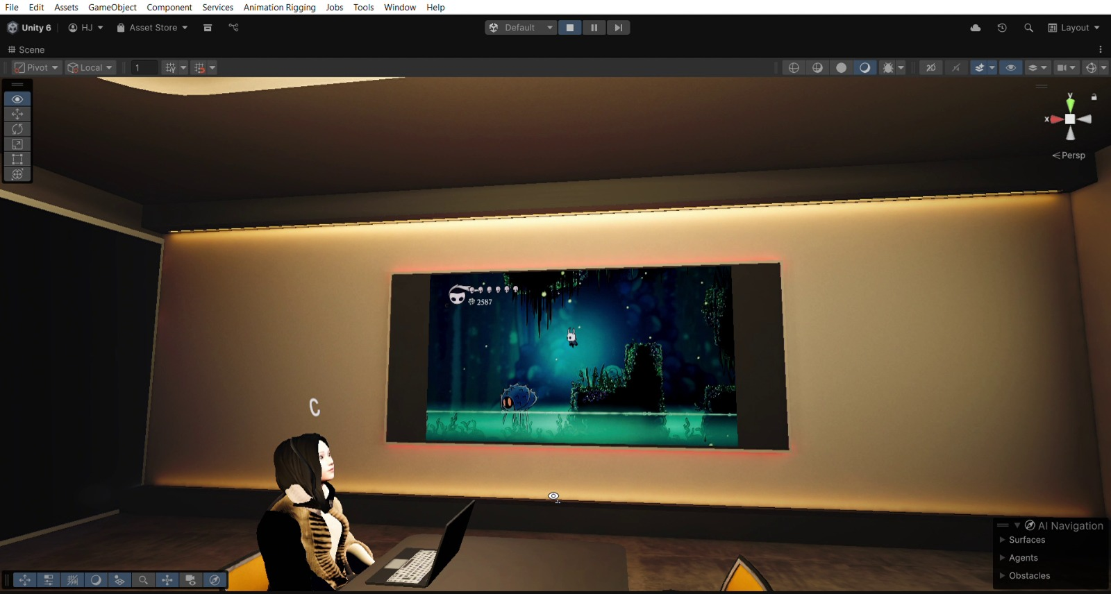
6.5 presentation Screen

Description : This scene showcases the presentation feature within the VR meeting room. A large wall-mounted display screen is shown actively streaming content, providing a clear and immersive visual experience for participants. An avatar is seated at the table with a laptop, illustrating how users can view and engage with shared media during a virtual meeting. The warm ambient lighting and organized layout enhance the professional atmosphere of the presentation environment.

  - Testing
  - Test Plan
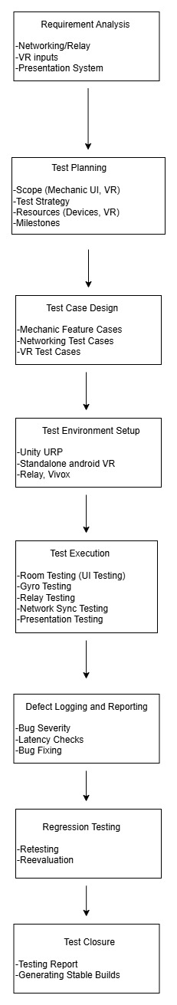
Fig 13 :Test Plan

- Test Case 1
Test case: 1 Test Case Name: Server Creation
Application: VR Meeting Room Subsystem: Unity Relay
Designed By: LI Design Date: 4th Nov,2025
Executed By: LI Execution Date: 4th Nov,2025
Short Description: Testing creation of Server

Pre-Conditions:
- Proper network conditions
- Meeting Room APK installed

Step | Action | Expected System Response | Pass/Fail | Comment
1 | Starting APK | Linking to unity cloud and Vivox authentication process | Pass | No problem while linking and authentication
2 | Pressing Create Button | Room, Room id and Vivox Channel Creation start | Pass | No problem while linking to cloud services
3 | Adding Participants | Shearing Id for participants to join | Pass | No problem with peer-to-peer connection
4 | Communication by Voice Chat | Participant can hear what the other person speak and also talk on voice chat | Pass | No problem in Vivox channel
5 | Setting Presenter | The presentation starts for required presenter | Pass | No problem with presentation
6 | Kicking participants | The kicked participant disconnected | Pass | No problem in UTP
7 | Ending Meet | All participants Disconnects | Pass | No problem in RPCs
Post-Conditions:
- Disconnected to network
- On UI scene after disconnect

Test Case 2
Test case: 2 Test Case Name: Server Joining
Application: VR Meeting Room Subsystem: Unity Relay
Designed By: LI Design Date: 4th Nov,2025
Executed By: LI Execution Date: 4th Nov,2025
Short Description: Testing joining on Server

Pre-Conditions:
- Proper network conditions
- Meeting Room APK installed
- Host Had Created the Server
- Room Id: VDLWA4
- Presentation exe Setup.

Step | Action | Expected System Response | Pass/Fail | Comment
1 | Starting APK | Linking to unity cloud and Vivox authentication process | Pass | No problem while linking and authentication
2 | Adding Details | Entering Name, presentation IP, room id: VDLWA4, avatar Selected | Pass | UI and other local system are working
3 | Pressing join Button | Session and Vivox channel joining states. | Pass | No problem while linking to cloud services
4 | Communication by Voice Chat | Participant can hear what the other person speak and also talk on voice chat | Pass | No problem in Vivox channel
5 | Setting Presenter | Able to see the computer screen on virtual laptop and presenter board while presentation | Pass | No problem with presentation
6 | Rotating Neak | The neck roates with respect to mobile gyro rotation and seeing other person’s neck rotation also | Pass | No problem in gyro inputs and RPCs
7 | Ending Meet | All participants Disconnects | Pass | No problem in RPCs and UTP

Post-Conditions:
- Disconnected to network
- On UI scene after disconnect

7.3 Test Reports by Peers

Peer testing was conducted by a diverse group of users from various academic and professional backgrounds. This was done to ensure the vr meeting room is not only technically functional but also usable, trustworthy, and accessible to its intended audience.
The following table summarizes the qualitative feedback and reports received:

Tester Name | Profile / Area of Expertise | Feedback / Report Summary
Gurnoor Singh | B.Tech (CSE) Student | "Avatar loading works most of the time but occasionally fails after a reconnect. UI is clean and interaction quality is smooth overall."
Harsh Lalwani | B.Tech (CSE) Student | "Server shutdown results in a Key Not Found Exception. Networking remains stable during general use but needs error-handling improvements."
Tanish Singla | B.Tech (CSE) Student | "Presentation screen syncing works but other clients sometimes experience slight delays. Minor jitter noticed during locomotion."
Hemant Jindal | B.Tech (CSE) Student | "Permissions are not prompted by the app. Avatar selection is slow to load. UI layout requires fixes for proper alignment."
Vansh Rattan | B.Tech (CSE) Student | "Experienced latency in presentation screen updates. Small lag spike occurs whenever a new user joins the session."
Aryan Sood | B.Tech (CSE) Student | "Audio and interaction stability are generally good. Gyro calibration issues appear occasionally along with minor server script warnings."

Conclusion :The VR Meeting Room application demonstrates solid progress and is generally stable, but several issues must be resolved before release. Key conclusions from peer testing include:
- Core functionality is working well, including avatar interaction, movement, and multiplayer synchronization.
- Networking is stable during normal operation, but server shutdown errors require immediate attention.
- Presentation features work, yet exhibit noticeable latency and occasional desync for other clients.
- UI and UX require refinement, particularly in layout alignment, permission prompts, and avatar selection speed.
- Minor performance issues—such as jitter, lag spikes, and gyro calibration errors—need optimization for a smoother user experience.
- Audio systems function reliably, with only small inconsistencies observed.
- A final regression test is necessary after implementing fixes to validate overall stability and readiness for deployment.

6. Change History

Version 1.0 (19-08-2025): Initial release
Version 1.1 (26-08-2025): Expanded with technology stack, functional requirements, and detailed specifications

7. References
- IEEE Computer Society, IEEE Recommended Practice for Software Requirements Specifications (IEEE Std. 830-1998). IEEE, 1998. [Online]. Available: https://standards.ieee.org
(Accessed: Oct. 12, 2025)

- Unity Technologies, “Netcode for GameObjects Documentation,” Unity Docs, 2025. [Online]. Available: https://cloud.unity.com/
(Accessed: Oct. 12, 2025)

- Unity Technologies, “Unity Relay Manual – Integration,” Unity Gaming Services Documentation. [Online]. Available: https://docs.unity.com/ugs/en-us/manual/relay/manual/integration
(Accessed: Oct. 12, 2025)

- Unity Technologies, “Vivox Unity – Communications & Safety,” Unity Gaming Services Documentation. [Online]. Available: https://docs.unity.com/ugs/en-us/manual/vivox-unity/manual/Unity/communications-safety
(Accessed: Oct. 12, 2025)

- Python Software Foundation, “Python Standard Library Documentation,” Python 3 Docs. [Online]. Available: https://docs.python.org/3/library/index.html
(Accessed: Oct. 12, 2025)

- Draw.io, “Draw.io – Free Diagram Software,” Draw.io. [Online]. Available: https://app.diagrams.net
(Accessed: Oct. 12, 2025)

